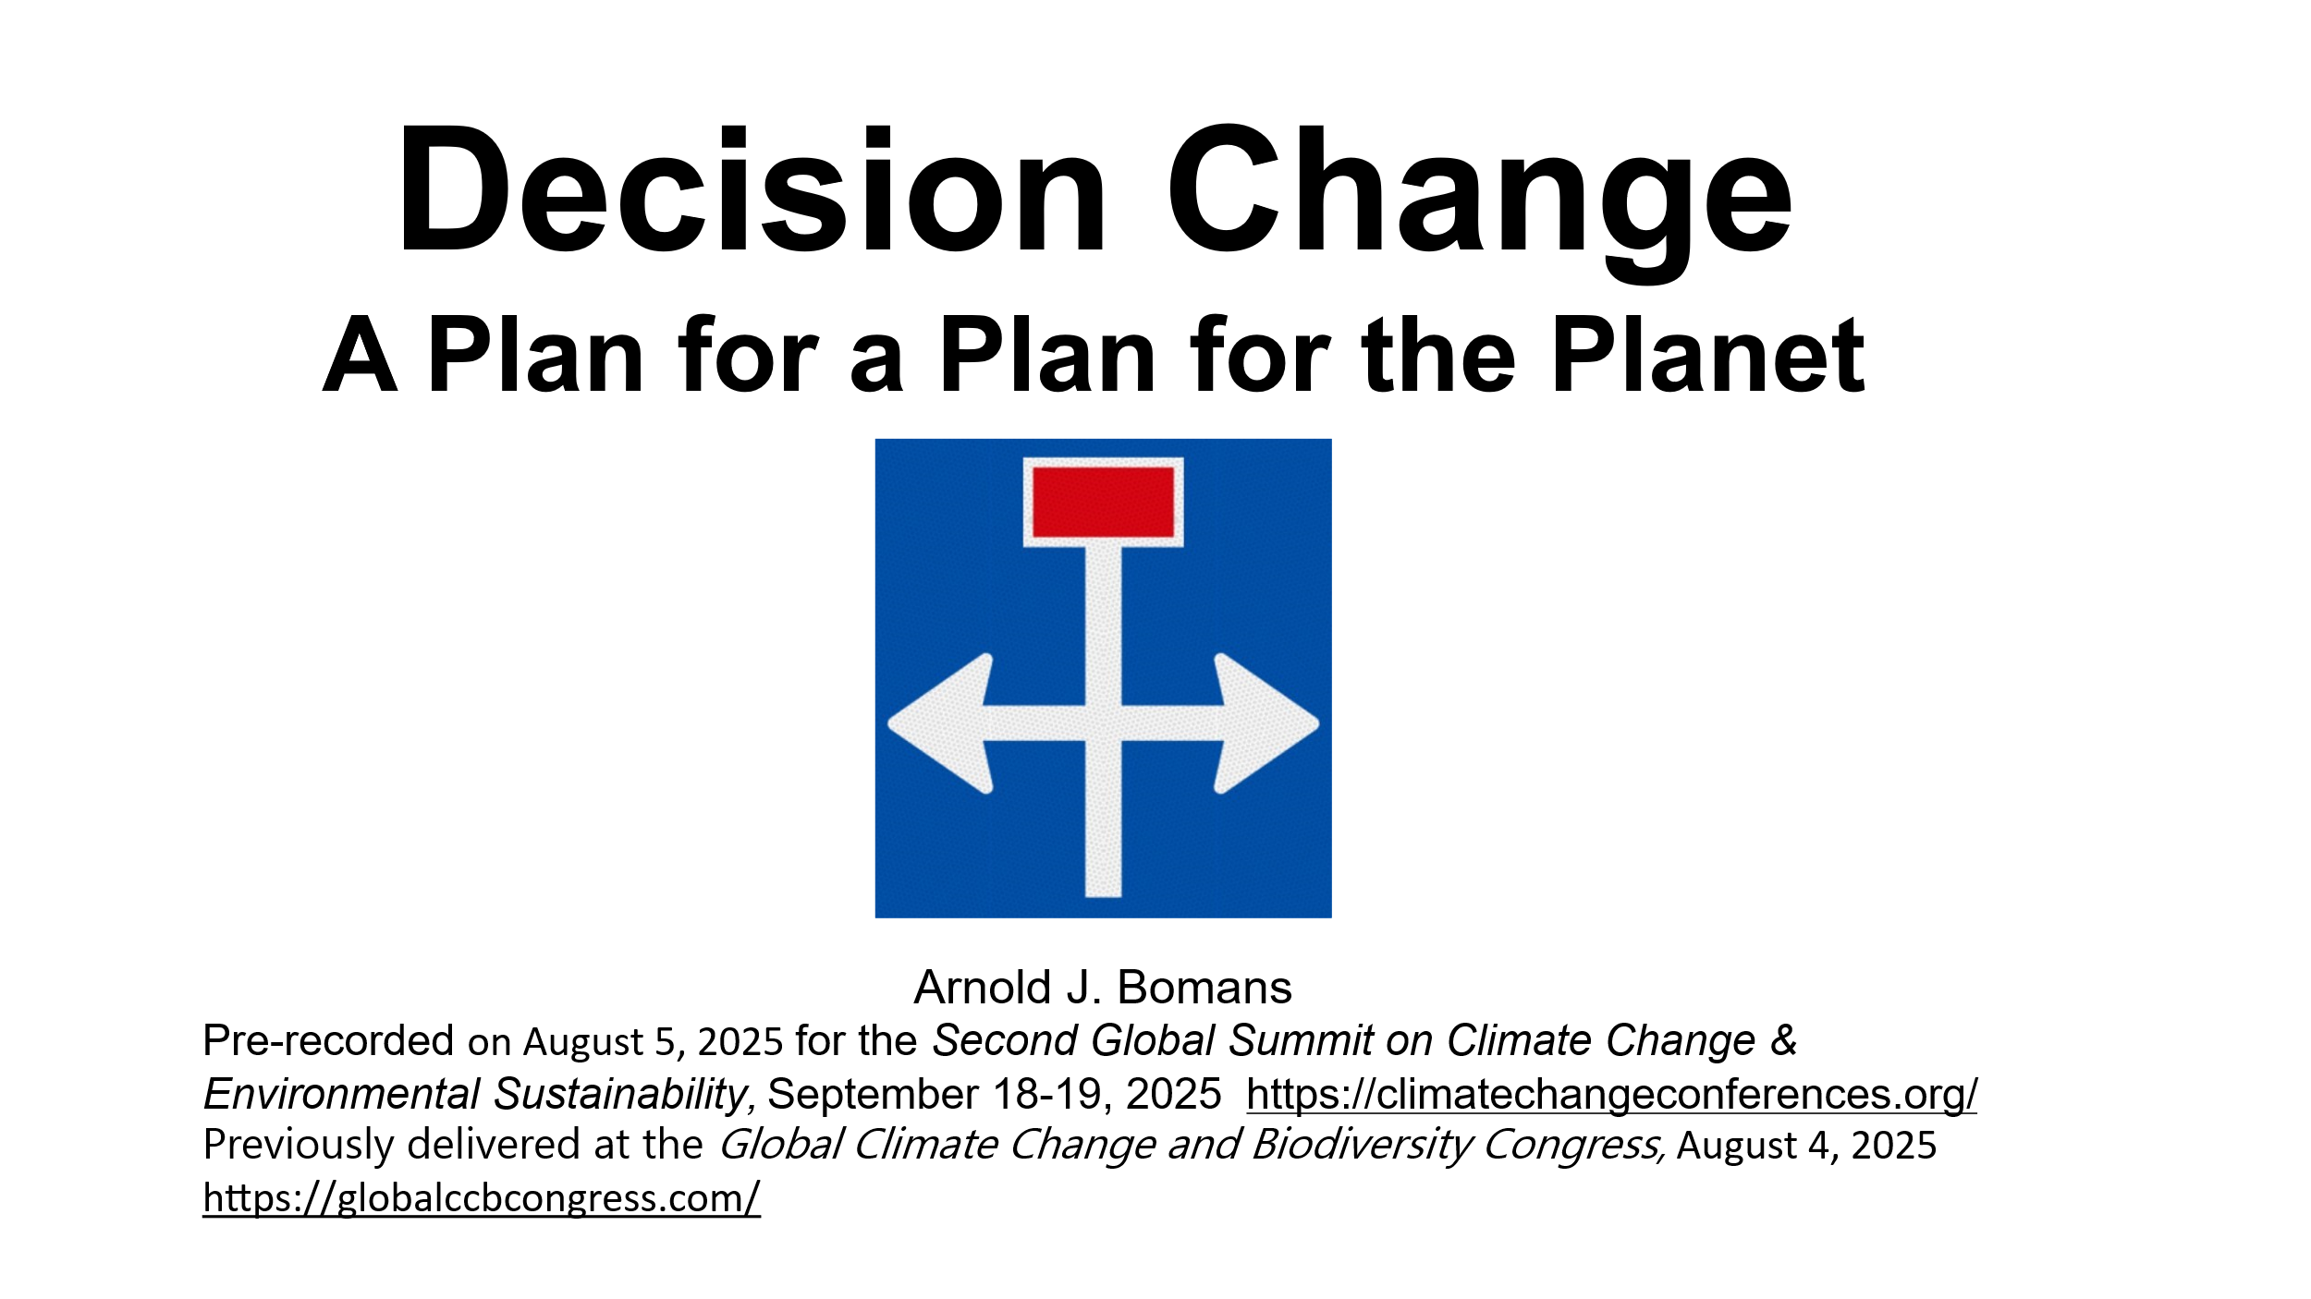
Dear summit attendants,
We are heading towards the thirtieth conference of the United Nations on climate change, COP30, which is shorthand for Conference of the Parties number thirty. COP30 should be a breakthrough because global coordination is needed to address climate change and other global crises. However, COP30 is expected to be far worse than frustrating, to say the least. The conclusion is simple: we need something else than the COPs. What would be a better way to decide on plans for the climate and other global issues? ... I don’t know...but in this talk, I will propose a way to answer this question: namely, a program for designing a better procedure to decide on systemic changes, and for putting this procedure to practice. Actually, this summit already made a start of this program. Let me explain.
Most of us are here to explore plans for containing climate change and for other environmental sustainability. And most of these plans have a global or fundamental impact. But procedures to decide on them at a global level leave much to be desired. So, how to best decide on global plans, perhaps your plan? It would seem that this question is effectively answered during the session on climate policy and governance. During this session, experts in some branch of decision-making (maybe you) explore ideas for procedures to decide on global plans. These decision-making experts may be authorities in their field, but it will take long before their proposed procedures or improvements are used to decide on global plans. If the experts themselves would agree on a decision-making procedure during this session, then they are with too few for their choice to be considered legitimate. So, how to best decide on a decision-making procedure? ... You might have guessed by now ... I propose that a great variety of decision-making experts (and laypeople) come together and actually design a procedure to decide on global plans. I call this design of a decision-making procedure decision change, and by ‘design’ I mean both the process of designing and the resulting design. The procedure would be used to let people other than the designers decide on global plans -- not only plans for containing climate change and for other environmental sustainability, but any systemic plans, that is, plans that have a global or fundamental impact.

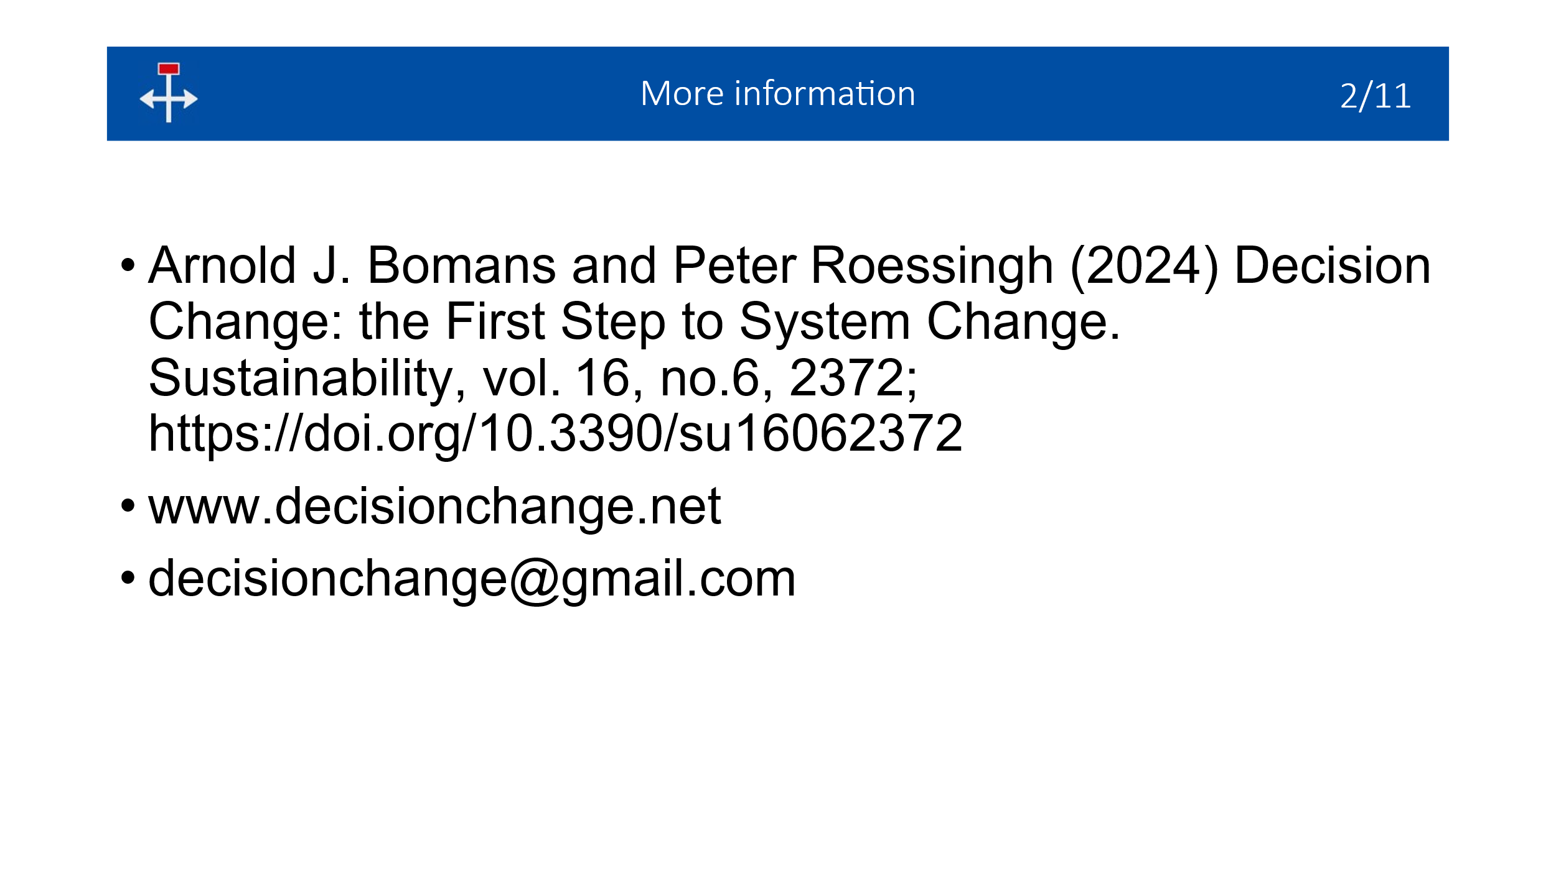With my co-author, Dr. Roessingh, I published the decision-change program in the peer-reviewed journal Sustainability of March 2024. My name is Arnold Bomans and I have a master’s in mathematical decision-making.
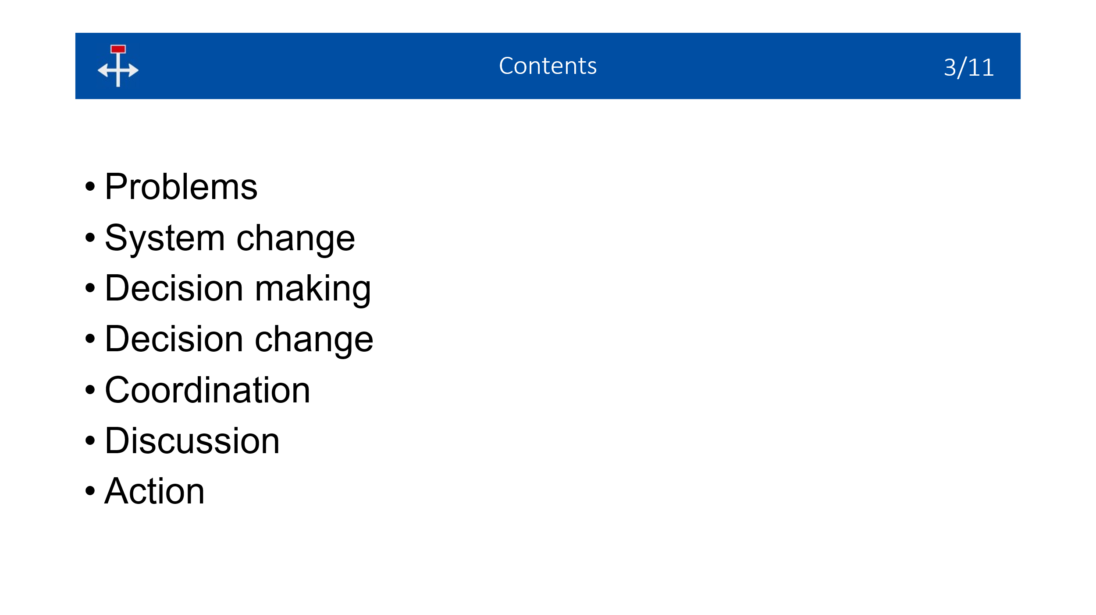Let me first overview the problems, then the systemic changes needed to address these problems, and next, decision-making on such systemic changes. Then I will describe the decision-change program, its coordination, and discuss some advantages and disadvantages. The conclusion will be a call to action.

Problems
So what are the problems and threats? To make sure that we are on the same page: Environmental problems and threats are global warming, biodiversity loss, pollution, resource depletion, diseases including pests, and invasive species. Non-environmental crises and threats are economic inequality or injustice, armed conflict, mass migration, political and economic instability, not to mention psychological crises and problems concerning information of all kinds. The list is even longer. Crises obviously may reinforce each other, in which case they are called a polycrisis.

System Change
To address these problems and threats most effectively, we need to consider them in their entirety, that is, we need systemic changes. The reasons are somewhat obvious but I want to briefly mention them because systemic changes are often overlooked or deemed impossible. I define system change as either a fundamental change or a change across the system.
Let’s first consider changes across the system. We often must suppress, or adapt to, the manifestations of global problems, the “symptoms” so to say. For example, geoengineering, which doesn’t remove the cause of global warming. The problem may also resurface, for example, we must remove plastic from the sea shores and oceans, but if nothing else changes, plastic will keep coming.
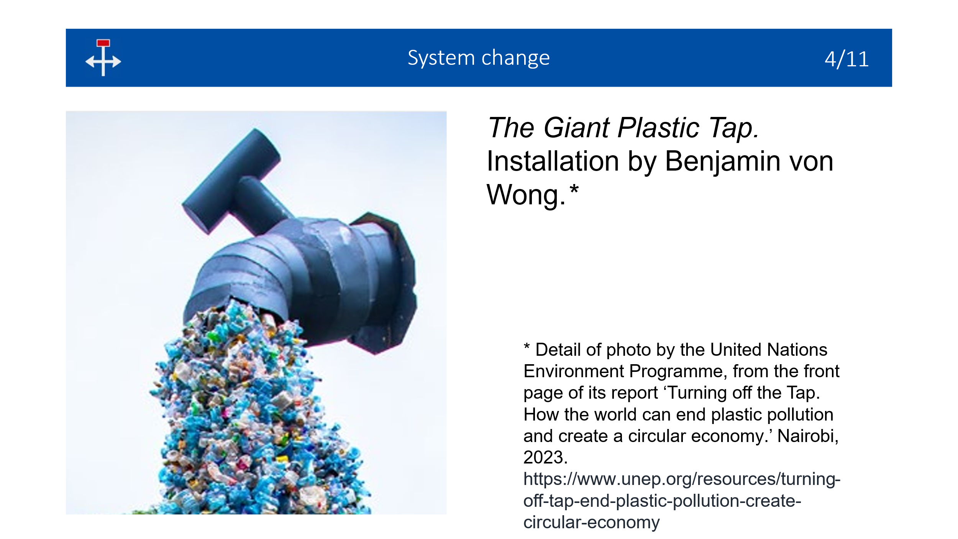It’s like mopping the floor with the tap open. Also, plastic is almost everywhere so there are not enough means to remove all plastic. It would seem that removing the cause of the problem is enough, but that may create or worsen another problem. For example, if we stop the production of plastic, then collectors of plastic garbage lose their jobs. Similarly, there are not enough metals for both batteries and construction works. Or: wind turbines at sea are ecologically harmful.
Therefore, we should address the common causes (in the sense of root causes) so that one measure may help to tackle multiple problems. That is, we need a fundamental approach. Options for it are consumption reduction (also called degrowth) or a national economy that maximizes some index of wellbeing instead of gross domestic product. There are other options that hardly anyone has heard of, especially for micro-economies. Therefore, it would be a good idea to obtain an overview of system-change proposals, conventional as well as unconventional.

Decision making
But how to decide on system-change proposals? How are such decisions made at present?
There are international non-governmental organizations that advocate systemic changes. For example, the Forest Stewardship Council promotes forestation. In brief, most such organizations, however, don’t coordinate their actions with each other very well.
Now for governments. Consider for example the combustion of fossil fuels, which is a common cause of several environmental problems, such as global warming, pollution, and many others due to population growth. Therefore, phasing out fossil fuels is a fundamental change. However, nations are reluctant to rapidly phase out on their own because other nations would only profit from it. Therefore, phasing out fossil fuels needs to be coordinated. (For the moment, I ignore the impact of phasing-out fossil fuels on society.) It took until COP28 before the term `phasing out fossil fuels’ was even mentioned in a declaration. However, at COP29, this topic wasn’t on the initial agenda and didn’t make it to a final declaration.
It's 2025 and COP30 approaches. The recent preparatory talks in the city of Bonn made no progress on plans for climate adaptation, phasing out fossil fuels, or paying one-trillion US dollar each year to the global south. Nevertheless, both governments and civil society groups hope that these conferences can still make a difference.
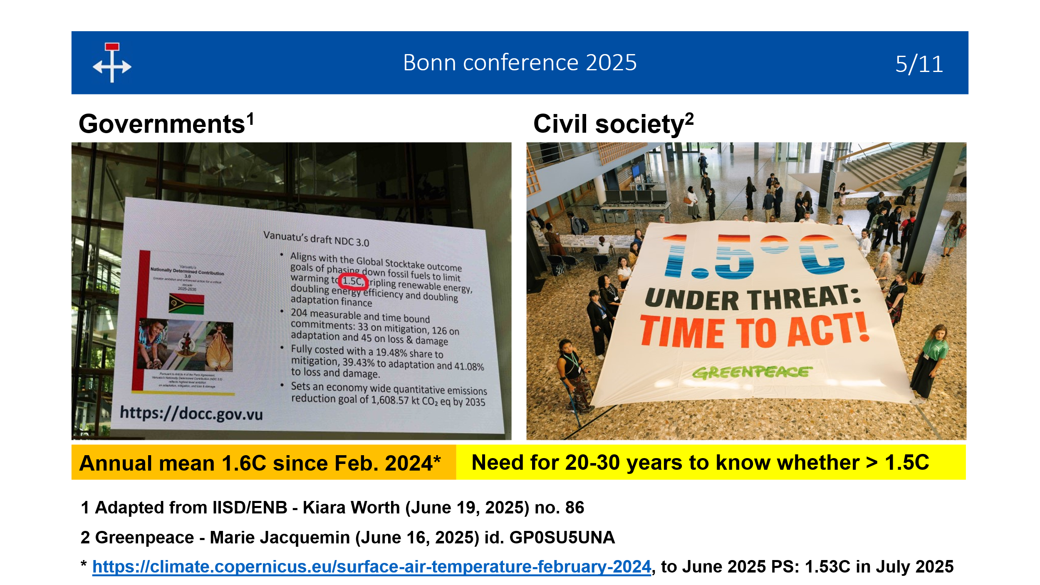For example, here we see a billboard in Bonn of the plan for reducing carbon emissions by the island state of Vanuatu. Only 5% of the parties have updated these plans in time. I have encircled `1.5C,’ the preferred limit of global warming as agreed in Paris.
And this is a banner, unfolded by Greenpeace, that warns that 1.5C is under threat.
Meanwhile, the climate catastrophe is also unfolding: The annual average is 1.6C since February 2024. Yet, the banner is correct because the passage of 1.5C can only be established as an average over several decades, although there is no consensus what the word `average’ should mean for temperatures that tend to increase.
It’s time to get realistic and recognize that these decision-making processes have failed to avert global warming -- and biodiversity loss for that matter. Of course, that’s not only the fault of these conferences.
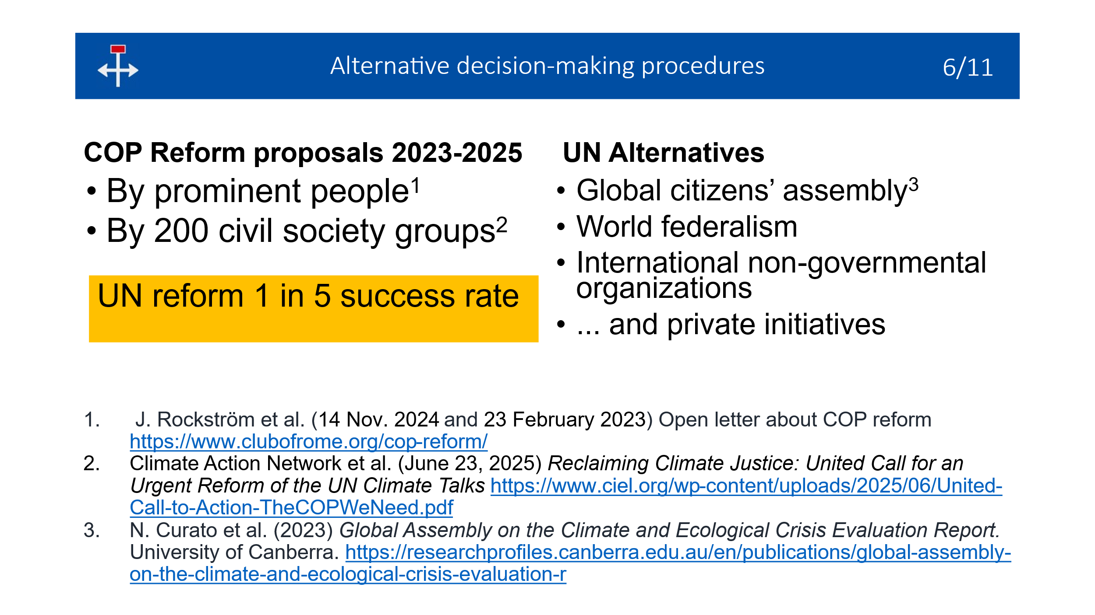There have been many calls to reform decision-making procedures of the United Nations, in particular of the COPs. Prominent people did so twice. Recently, twohundred groups of civil society made a similar call. However, these proposals are seldom put on the agenda and generally, UN reforms have a one-in-five chance of succeeding.
Alternatives to the UN have also been proposed. For example, hundred randomly chosen world citizens deliberated about climate change and biodiversity loss; there is the older idea of world federalism, which is a world government based on subsidiarity; we have many international non-governmental organizations in place; and so on. Let’s not forget private initiatives, like by industry.
These procedures are intended for governance, which I define as repeated decision-making. Choosing one mode of governance I consider a case of system change. But how to select a mode of governance and other system change? Such selections have already been made, such as by academia, the Global Challenges Foundation, and the Stimson Center, but with very limited success.

Decision change
For a better selection of a mode of governance, or rather, of a procedure to decide on system change, let’s consider the large body of knowledge which is called `decision-making science’ or `decision science’.
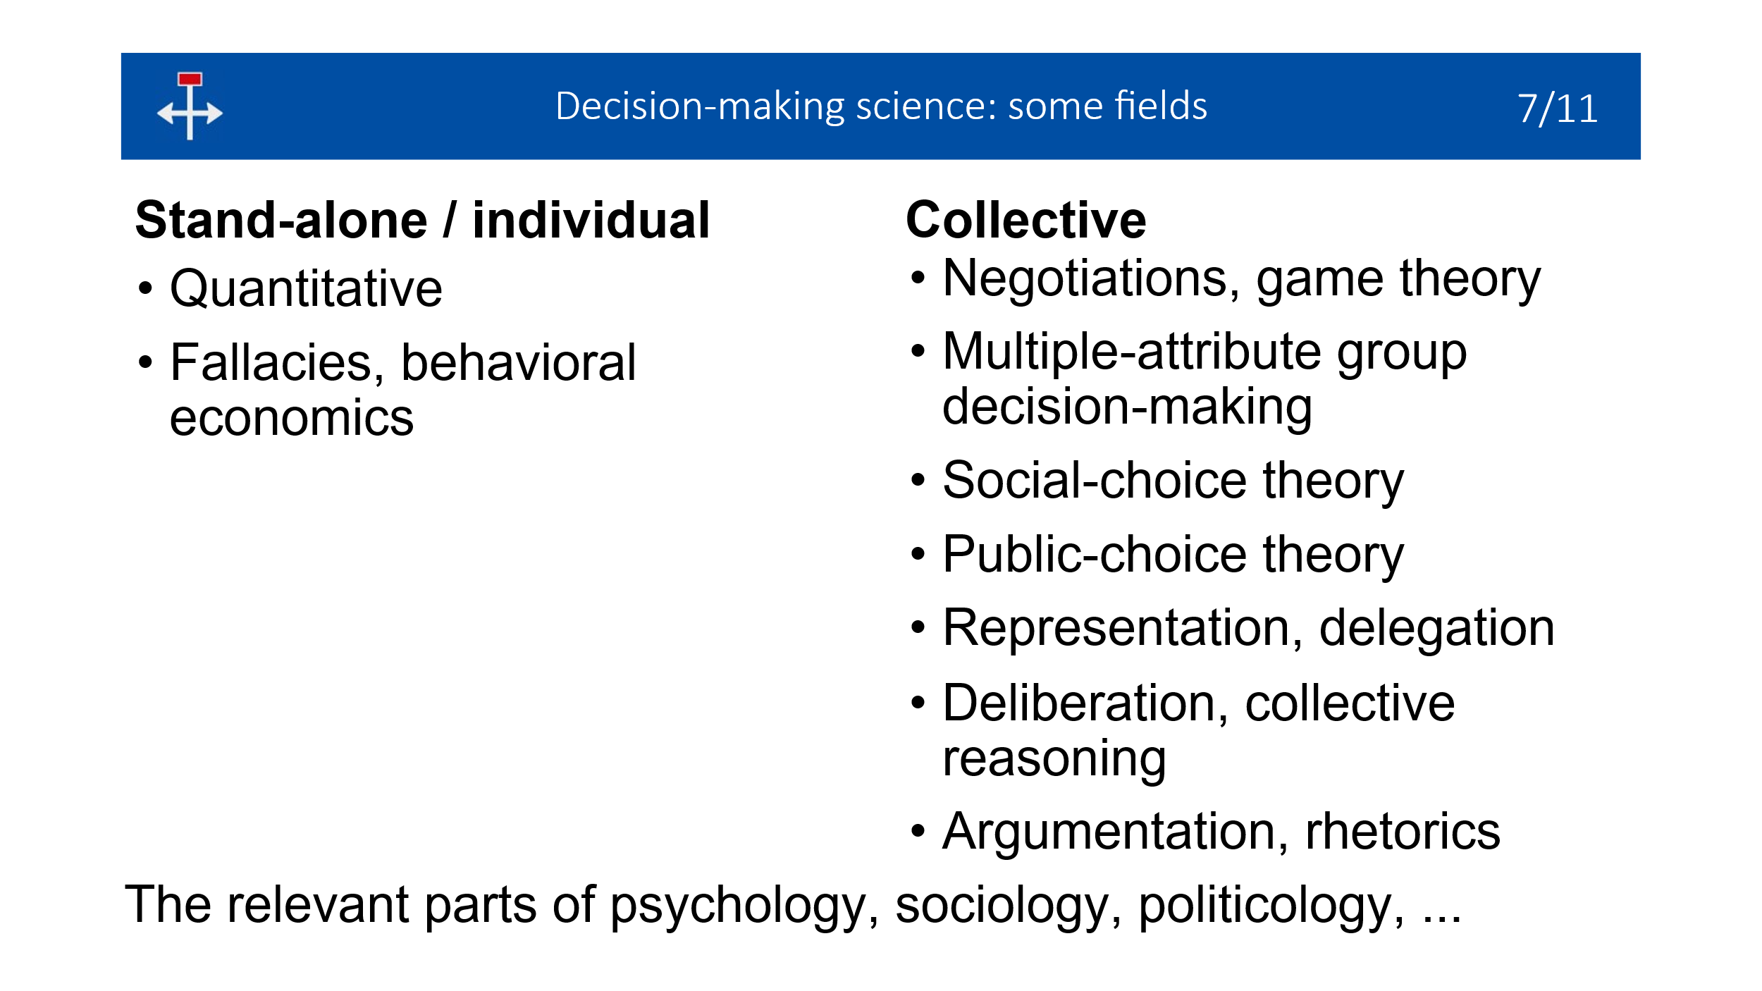The term currently is used in various senses -- one time for quantative decision-making (optimization, statistics) and another time for individual decision-making (fallacies of reasoning, and cognitive psychology such as investigated in behavioral economics). By `collective decision-making’ is mostly meant mathematical game theory, often used to analyze negotiating and bargaining. I would like to let the term ‘decision science’ also cover many other fields: multiple-attribute group decision-making; social-choice theory, which is a mathematical approach to collective decision-making, such as voting methods, often geared at discouraging strategic behavior. Then there is public choice theory, which considers politics economically, as the maximization of a kind of profit. Further, representation and delegation (for example, liquid democracy). Another area of expertise is deliberation and its social dynamics (such as with citizens’ assemblies), and collective reasoning. Last but not least, analyzing someone else’s argumentation or using rhetorics oneself is another discipline in its own right.
The relevant parts of other fields of expertise should be included, such as psychology, sociology, and politicology.
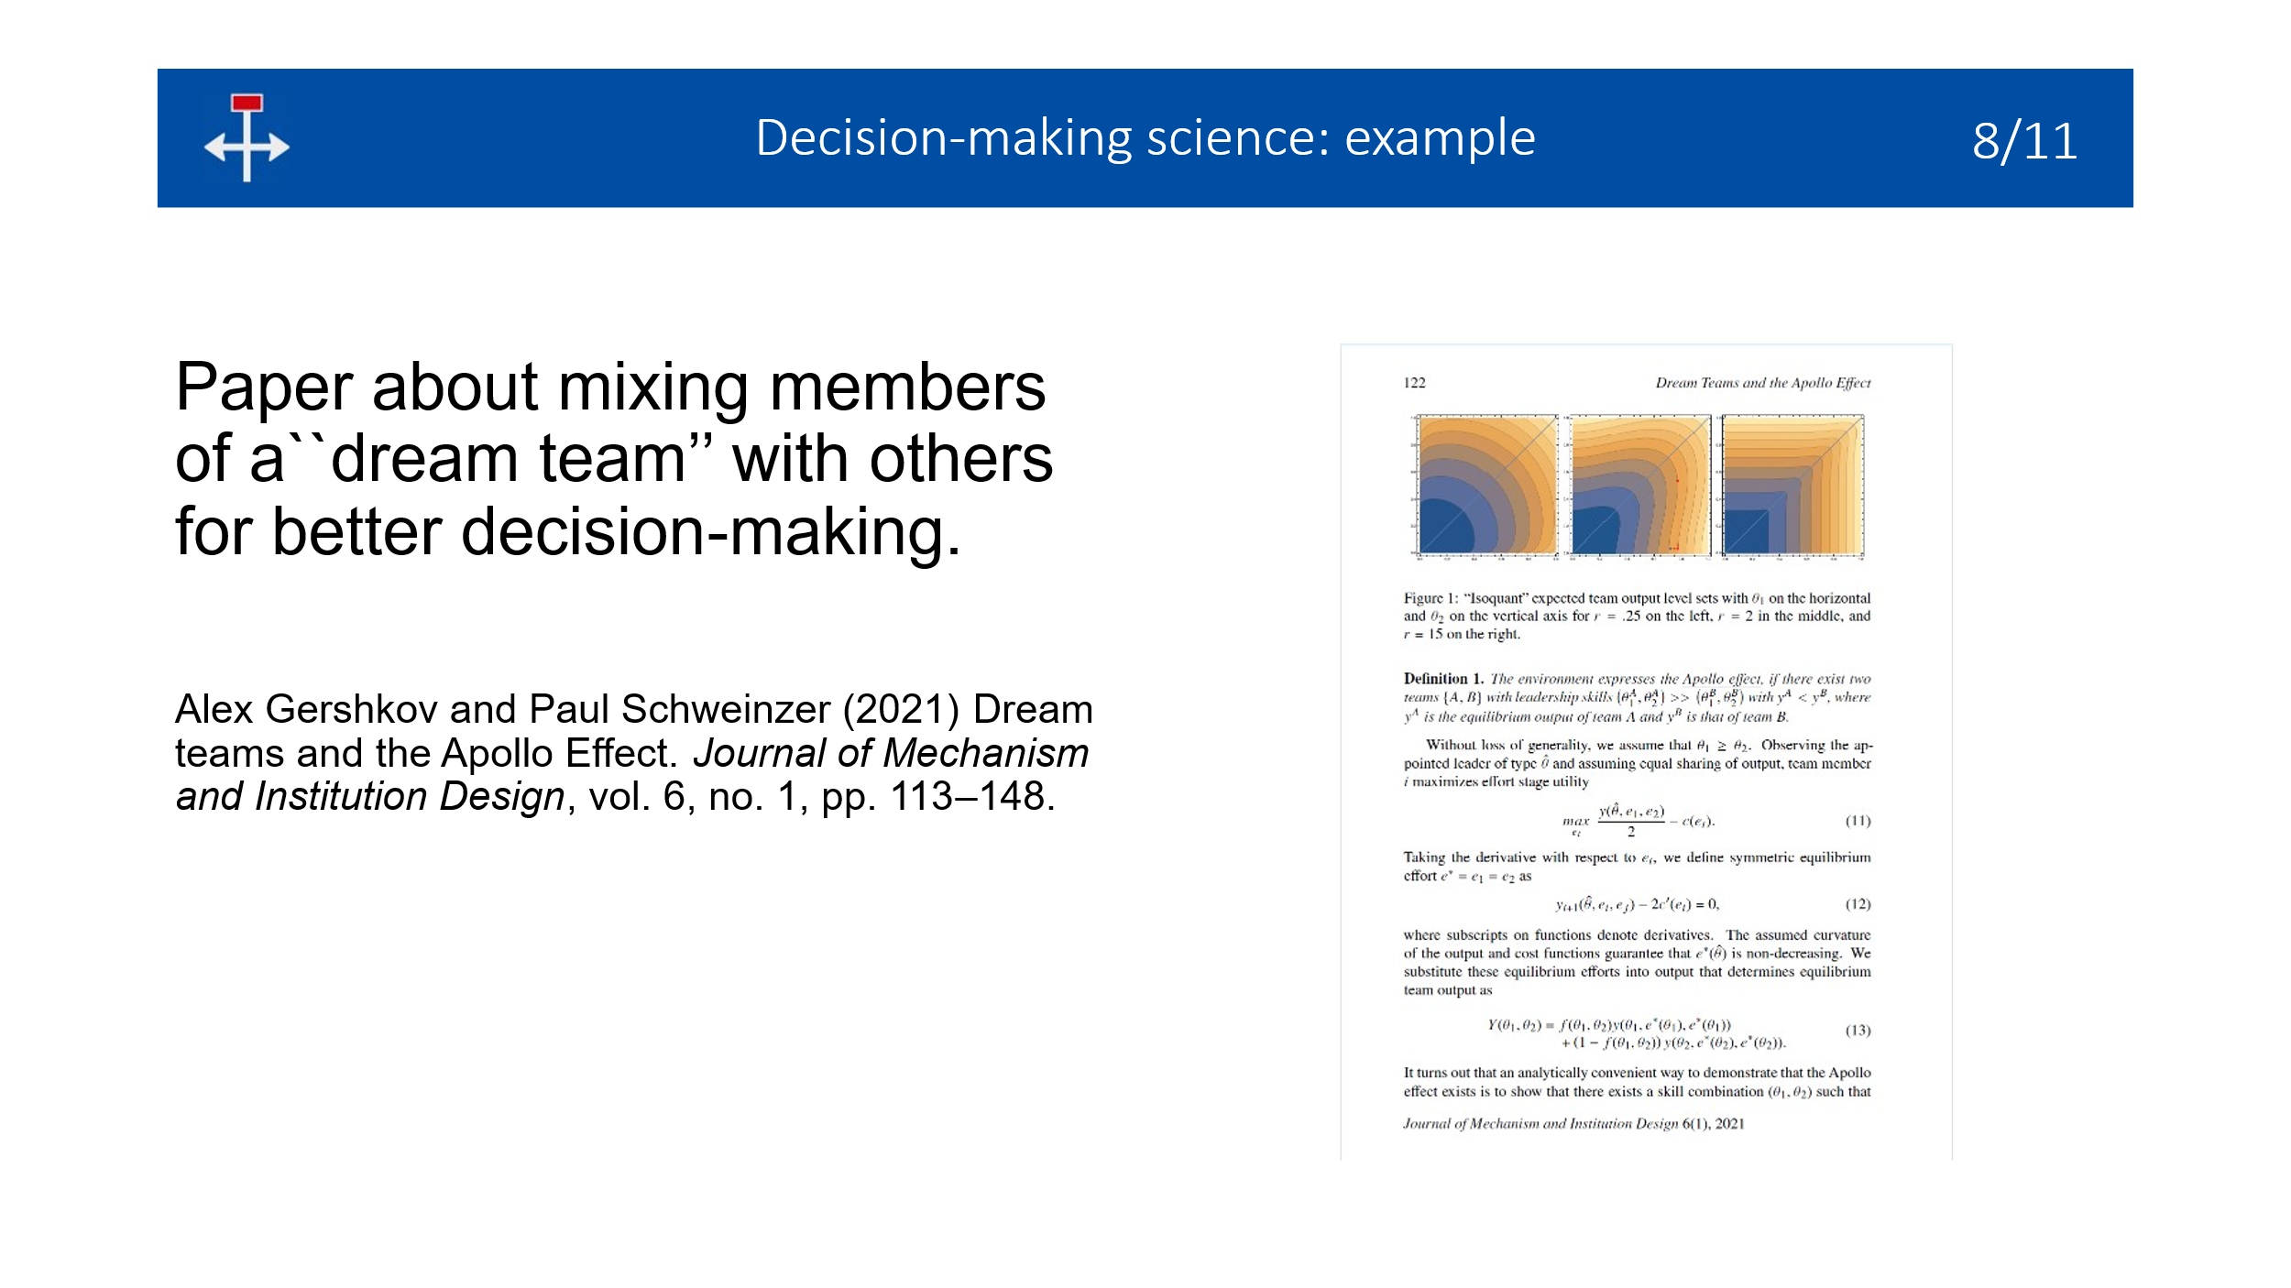To illustrate an unconventional approach to decision-making, on the right-hand side you see a page of a publication about “dream teams,” that is, groups of high-performing people. Collectively, these people however tend to take very bad decisions, so such a team should be mixed with others to improve decision-making and leadership selection. As you can guess from this page, this topic can be approached objectively and numerically.
By the verb `to decide’ I also mean to design. But before rushing to further designing systemic changes, a problem analysis is mandatory. That in turn requires goal-setting and perhaps even shifts of our paradigms or mindset, because these are at the heart of the matter.
All in all, I propose to tap all these fields of expertise and let experts in collective decision-making (and others) design a procedure to decide on systemic changes. Such design has been done before, namely, the selection of a voting procedure in various circumstances.
Now, the decision-making experts probably will be the first to insist that laypeople should be involved in the design process. Reasons are that a ``dream team’’ of decision-making experts may take bad decisions, and that a mix of people guarantees a more legitimate design process.
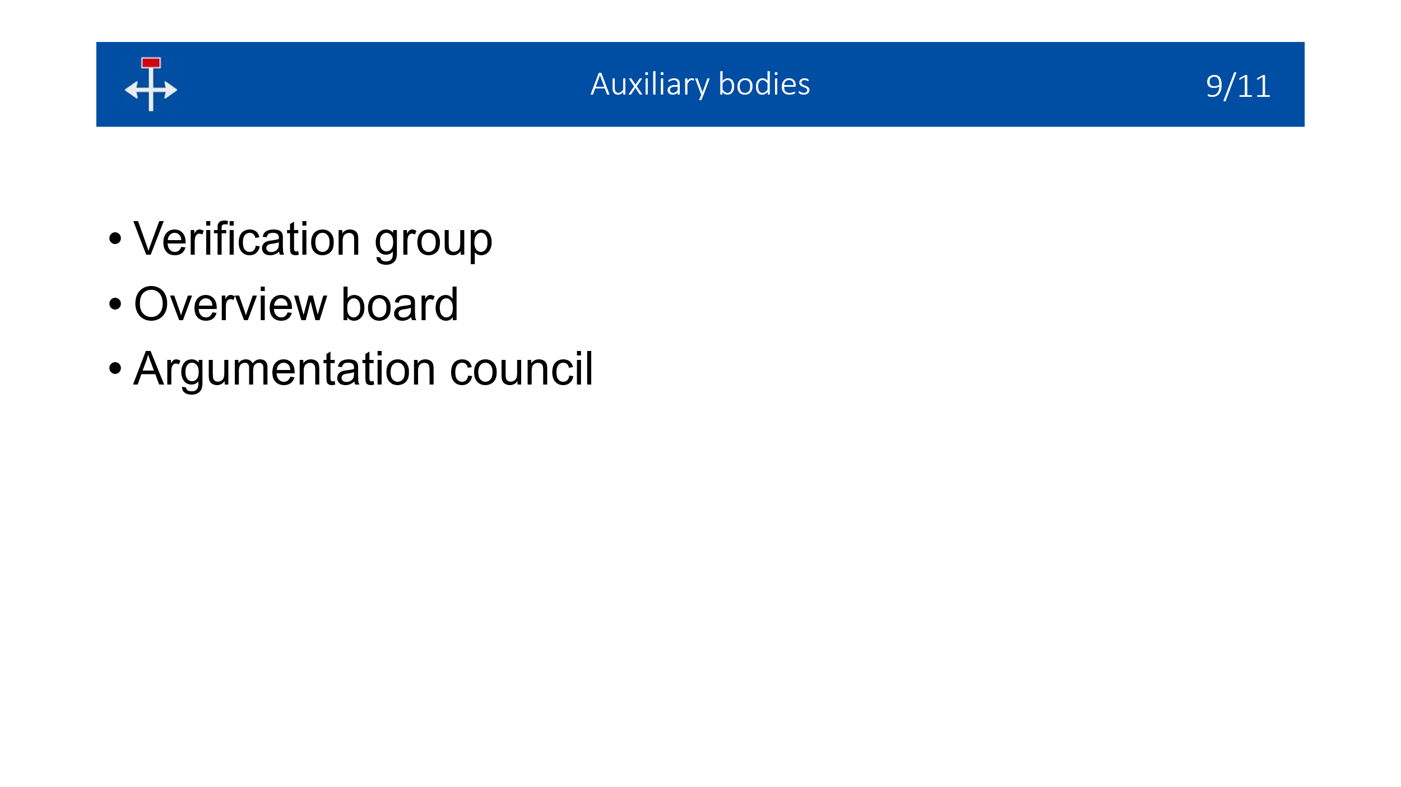This design process should also be safeguarded by what I call auxiliary bodies. I suggest the following.
- A verification group to test the design and comment on it.
- An overview board to ensure that the designers are independent and of all kinds.
- An argumentation council to guarantee that the design document is a complete and consistent text, irrespective of its contents, and not a collection of “hurray-words,” that is, hollow words that only have a positive connotation which nobody dares to criticize.
This is only a suggestion -- it is up to the decision-making experts to determine what the auxiliary bodies should look like.

Coordination
Now about the coordination of this design process.
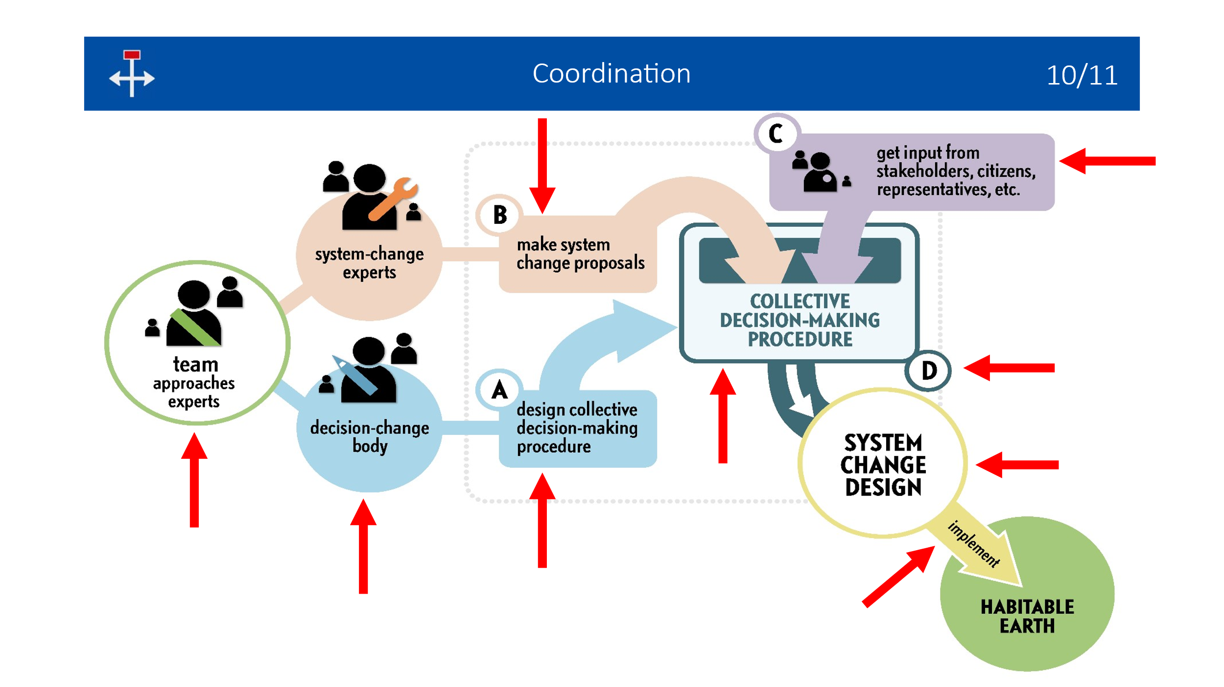A global coordinating team should bring together the decision-change body, that is, the decision-making experts, laypeople, and the auxiliary bodies. Its members do not decide themselves on systemic changes but they (A) design a procedure with which others decide on systemic changes. The team should also gather system-change proposals from (B) domain experts (to be extended by (C) the public), thus tapping into an untapped potential of ideas. The team must guarantee that some institution uses the (D) resulting procedure to decide on (or design) system change, but actually organizing the decision-making wouldn’t fall under the team’s remit, let alone actually implementing the resulting measures.

Discussion
Let’s consider the pros and cons of this program.
The necessary measures may be considered legitimate because they have been decided on using a well-designed procedure that was applied to a wide range of system-change proposals.
However, the measures may be hard to bear. For example, stopping combustion of fossil fuels and biomass may decimate energy supply. The extent to which the general public will oppose such measures, is hard to predict, but vested interests (industry and governments) are likely to oppose alternative decision-making procedures. You can find more about advantages and disadvantages in the paper. In any case, just preparing for COP31 is equal to accepting further collapse.

Action
What can you do? You can approach an established, independent organization, such as a business, that forms the team to do most of the administrative work. The organization needn’t have all the personnel and money -- it may outsource this work to a project bureau annex conference organizer and obtain independent funding. However, the organization would retain the responsibility of letting the team perform its task and of guaranteeing follow-up, that is, of finding an institution that organizes the actual decision-making.
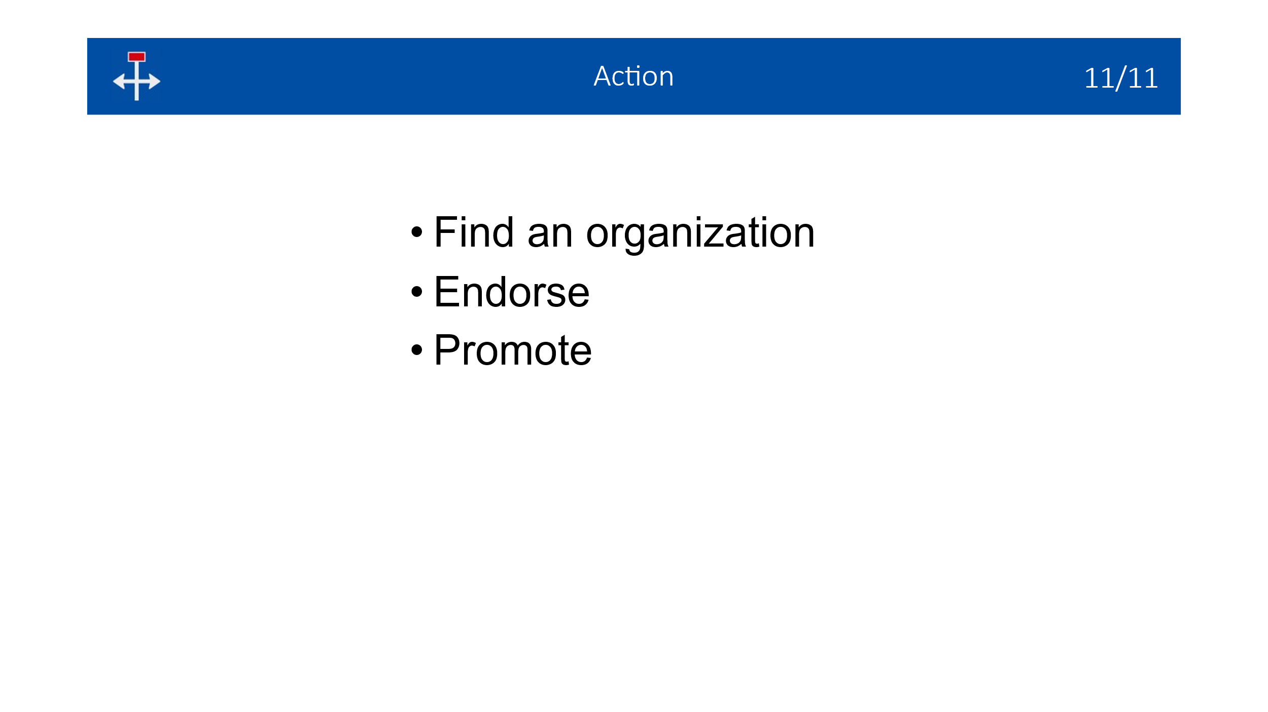The desired organization could be your university or research institute (if you are affiliated to one), but if it doesn’t set decision change in motion, then you can send a statement of endorsement. Finally, you can promote decision change by referring to it in various media.
So this is how an alternative to the COPs can be designed and how you can assist. The result will be a well-designed procedure to decide on system change -- a plan for a plan for the planet.

Fiona Harvey (June 27, 2025) Wreckers, money woes and mutirão: 10 things we learned about Cop30 from Bonn climate talks. The Guardian. https://www.theguardian.com/environment/2025/jun/27/cop30-10-things-we-learned-from-bonn-climate-talks
M. Lawrence, T. Homer-Dixon, S. Janzwood, J. Rockström, O. Renn, J.F. Donges (2024) Global polycrisis: the causal mechanisms of crisis entanglement. Global Sustainability. Vol.7, e6. https://doi.org/10.1017/sus.2024.1
A.Koschinsky, L. Heinrich, K. Boehnke, J.C. Cohrs, T. Markus, M. Shani, P. Singh, K. Smith Stegen, and W. Werner (Nov. 2018). Deep-sea mining: Interdisciplinary research on potential environmental, legal, economic, and societal implications. Integrated Environmental Assessment and Management. Volume 14, number 6, pages 672–691. https://doi.org/10.1002/ieam.4071
F. M. Platjouw, S. Trubbach, L. Friedrich, G. Sander, B. Boteler, C. Passarello, and J. Kyrönviita (2025). Handbook on Policy Coherence – An easy guide to assess and understand policy coherence. CrossGov Deliverable 4.2. https://doi.org/10.5281/zenodo.15551116 On page 5 and page 20 (second example).
Tariel Mórrígan (2010). Peak Energy, Climate Change, and the Collapse of Global Civilization: The Current Peak Oil Crisis. Global Climate Change, Human Security & Democracy, Orfalea Center for Global & International Studies, University of California, Santa Barbara. https://content.csbs.utah.edu/~mli/Economics%207004/Morrigan_2010_Energy_CC4.pdf On page 98.
Civicus staff (July 16, 2025) Climate: Bonn talks fail to bring breakthrough. Civicus Lens. https://lens.civicus.org/climate-bonn-talks-fail-to-bring-breakthrough/

